|  |  |  |  |  |  |  |  |  |  |
| --- | --- | --- | --- | --- | --- | --- | --- | --- | --- |
| NUMBER | SLAVE ID | FUNCTION CODE |  | ADDRESS REGISTER*1 |  | NUMBER OF REGISTER*2 | CRC SUM |  | RESULT DATA  (BYTE) |
| 1 | 3C | 03 | 00 | 00 | 00 | 01 | 80 | E7 | 4,5 |
| 2 | 3C | 03 | 00 | 01 | 00 | 01 | D1 | 27 | 4,5 |
| 3 | 3C | 03 | 00 | 02 | 00 | 01 | 21 | 27 | 6,7 |
| 4 | 3C | 03 | 00 | 03 | 00 | 01 | 70 | E7 | 4,5 |
| 5 | 3C | 03 | 00 | 04 | 00 | 01 | C1 | 26 |  |
| 6 | 3C | 03 | 00 | 05 | 00 | 01 | 90 | E6 |  |
| 7 | 3C | 03 | 00 | 06 | 00 | 01 | 60 | E6 |  |
| 8 | 3C | 03 | 00 | 07 | 00 | 01 | 31 | 26 |  |
| 9 | 3C | 03 | 00 | 08 | 00 | 01 | 01 | 25 |  |
| 10 | 3C | 03 | 00 | 09 | 00 | 01 | 50 | E5 |  |

**Weather Station RS485**

*1 Address starting to read

*2 Number of register that you want to read

3C 03 00 00 00 02 C0 E6 (Read 2 registers from 0,1)

3C 03 00 00 00 17 01 29(Read 23(17 Hex) registers from 0 – 22)

How to determine the CRC SUM:

1. Go to this website <https://crccalc.com/>
2. Add the cmd address ( Ex: 3C 03 00 00 00 01)
3. Choose Input Type: Hex and Output Type: Hex
4. Choose Calc CRC-16
5. Look at CRC-16/ Modbus (Ex: E780)
6. The correct command is 80 E7

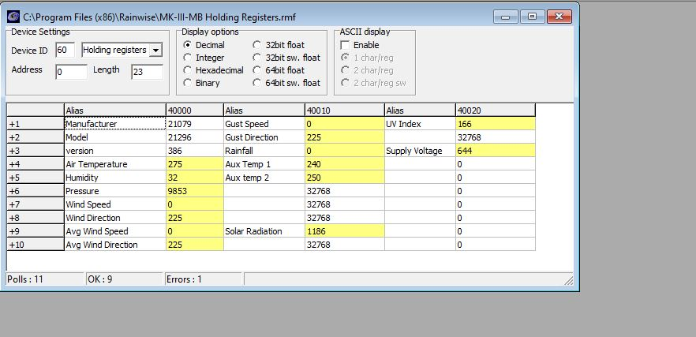

3C 03 00 00 00 17 01 29(Read 23(17 Hex) registers from 0 – 22)

Response:

3C 03 1,2

0D 0A

2E 3

52 57 21079 4,5 Manufacturer

53 30 21296 6,7 Model

01 82 386 8,9 Version

01 14 264 10,11 Air Temperature

00 20 32 12,13 Humidity

26 7D 9741 14,15 Pressure

0A 89 2697 16,17

00 00 0 18,19 Wind Speed

00 E1 225 20,21 Wind Direction

00 00 0 22,23 AVG Wind Speed

00 E1 225 24,25 Avg Wind Direction

00 00 0 26,27 Gust Speed

00 E1 225 28,29 Gust Direction

00 00 0 30,31 Rainfall

0D 0A 3338 32,33

00 E2 226 34,35

00 E1 225 36,37

80 00 32768 38,39

80 00 32768 40,41

80 00 32768 42,43

04 A6 1190 44,45 Solar Radiation

80 00 32768 46,47

00 0D 13 48,49

0A 50

A9 169 51 UV Index

80 00 32768 52,53

02 84 644 54,55 Supply Voltage

84 64 33892 56,57

0D 0A 3338 58,59

AMI RTU RS485

Temp

Humidity

Pressure

Windspeed 5 min avg

Wind Direction 5 min avg

Wind Gusts

Rain Fall

|  |  |  |  |  |  |  |  |  |  |  |  |
| --- | --- | --- | --- | --- | --- | --- | --- | --- | --- | --- | --- |
| DESCRIPTION | NUMBER | SLAVE ID | FUNCTION CODE |  | ADDRESS REGISTER*1 |  | NUMBER OF REGISTER*2 | CRC SUM |  | RESULT DATA  (BYTE) | DATA (EX) |
| Air Temperature | 4 | 3C | 03 | 00 | 03 | 00 | 01 | 70 | E7 | 4,5 | 01 18 |
| Humidity | 5 | 3C | 03 | 00 | 04 | 00 | 01 | C1 | 26 | 4,5 | 00 21 |
| Pressure | 6 | 3C | 03 | 00 | 05 | 00 | 01 | 90 | E6 | 4,5 | 26 79 |
| Wind Speed | 7 | 3C | 03 | 00 | 06 | 00 | 01 | 60 | E6 | 4,5 | 00 00 |
| Wind Direction | 8 | 3C | 03 | 00 | 07 | 00 | 01 | 31 | 26 | 4,5 | 00 E1 |
| Avg Wind Speed | 9 | 3C | 03 | 00 | 08 | 00 | 01 | 01 | 25 | 4,5 | 00 00 |
| Avg Wind Direction | 10 | 3C | 03 | 00 | 09 | 00 | 01 | 50 | E5 | 4,5 | 00 E1 |
| Gust Speed | 11 | 3C | 03 | 00 | 0A | 00 | 01 | A0 | E5 | 4,5 | 00 00 |
| Gust Direction | 12 | 3C | 03 | 00 | 0B | 00 | 01 | F1 | 25 | 4,5 | 00 E1 |
| Rain Fall | 13 | 3C | 03 | 00 | 0C | 00 | 01 | 40 | E4 | 4,5 | 00 00 |